Synopsis

Project Title
Clinical Risk Assessment for Type-2 Diabetes

Problem Id : 7

Name: Deepanshi Choudhary
University Roll number: 2028698
Name: Jahnavi
University Roll number :2028435
Name :Anvi Shandilya
University Roll number: 2028395

Section: P

- Problem Description:
Type-2 Diabetes is a chronic health condition that affects how the body processes blood sugar (glucose). Early diagnosis plays a crucial role in preventing severe long-term complications such as heart disease, kidney failure, and nerve damage. However, identifying individuals at risk in early stages can be challenging without proper data analysis.
This project aims to build a machine learning-based clinical risk assessment system using synthetic health data. The dataset will include features such as Body Mass Index (BMI), insulin levels, and age, which are key indicators of diabetes risk. By applying data preprocessing techniques and classification algorithms, the system will predict whether a person is at risk of developing Type-2 Diabetes.
The model will help in understanding patterns in health data and assist in early diagnosis, making it valuable in real-life healthcare scenarios such as screening programs and preventive medicine.

- Steps of Implementation:
1.Health Data Synthesis: Generate a dataset of 250 records based on realistic medical ranges for BMI, insulin levels, and age.
2. Data Preprocessing: Clean and organize the dataset for analysis.
3. Label Encoding: Convert categorical output (e.g., diabetic / non-diabetic) into numerical form.
4. Feature Scaling: Apply StandardScaler to normalize the data.
5. Model Building: Use Logistic Regression for classification.
6. Model Training & Testing: Split data into training and testing sets.
7. Evaluation: Use confusion matrix with focus on recall to evaluate performance.

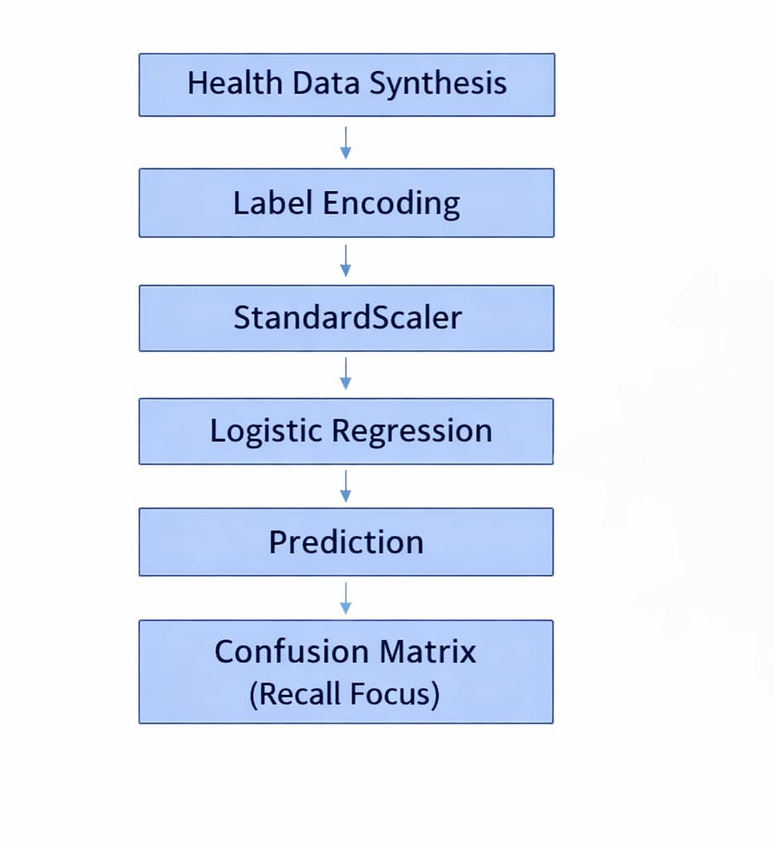.
Fig1: Sample architecture
- Expected Modules/ Libraries to be used :
- NumPy: For numerical operations and data handling.
- Pandas: For dataset creation and manipulation.
- Matplotlib / Seaborn: For data visualization and plotting graphs.
- Scikit-learn: For ML models, preprocessing, and evaluation metrics.
- Random: For generating synthetic dataset values.

- Expected Evaluation metrics and Plots to be used:
- Confusion Matrix: To evaluate model performance by comparing predicted and actual values.
- Recall Score: Important for identifying actual diabetic cases correctly.
- Accuracy: Measures overall correctness of the model.
- Precision: Helps in understanding false positives.
- Plots:
  - Scatter plots (BMI vs Age, Insulin vs Outcome)
  - Heatmap of confusion matrix

- Required topics from the Subject
- Strings: Used for handling categorical labels and data representation.
- Pointers: Helps in understanding memory handling in lower-level implementation concepts.
- Files: Used to store and read dataset (CSV format) for training the model.

- Platform Required:
- Jupyter Notebook
- Python IDE (VS Code / IDLE)

- Books and Link Sources:
- Introduction to Machine Learning with Python – Andreas Müller
- Hands-On Machine Learning – Aurélien Géron
- Scikit-learn Documentation
- Python Official Documentation

